

Search

David Murphy

01 August [Development](https://messapps.com/tag/development/)

**How To Install Xcode & Start Your First Project**

***NOTE:*** You must have access to an **Apple ID** account: to register, [**click here**](https://appleid.apple.com/account#!%26page%3Dcreate). For this method, **Xcode** and **Command Line Tools** are only accessible via Mac and other iOS Devices.

Apple provides Mac devs with both **Xcode** and **Command Line Unix Tools**, but you'll need to access Apple's servers first in order to reach them:

## Installing Xcode…

Access your Mac’s **Terminal Application** or what’s otherwise referred to as the **Console**; anything typed into this terminal is sent straight to your device’s Operating System:

Press “**Command + Spacebar**” to access **Spotlight Search**

Type in the word “**Terminal**” into the **Spotlight** search field and hit **Enter**; this should execute your Mac’s **Terminal** app

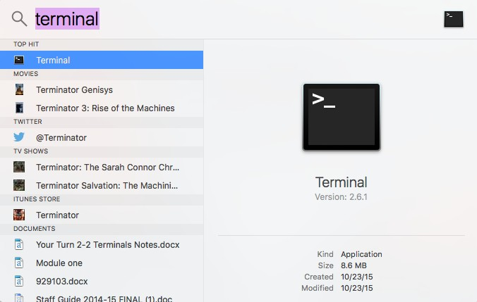

Type “**gcc**” into the terminal and hit**Enter** (gcc is a compiler that turns source code into executable applications). Alternatively, typing “**xcode­select ­­install**” into the terminal works just as well.



Before installing Xcode Command Line Tools, click **Get Xcode**

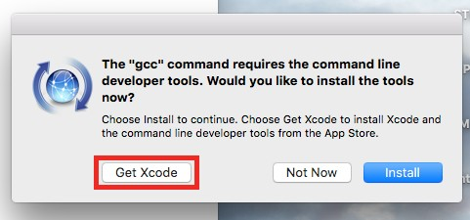

In order to install **Xcode** from the App Store, you’ll need to first log­in through your **Apple Id**. If you haven’t already created one, [**you can do so by clicking here**](https://appleid.apple.com/).

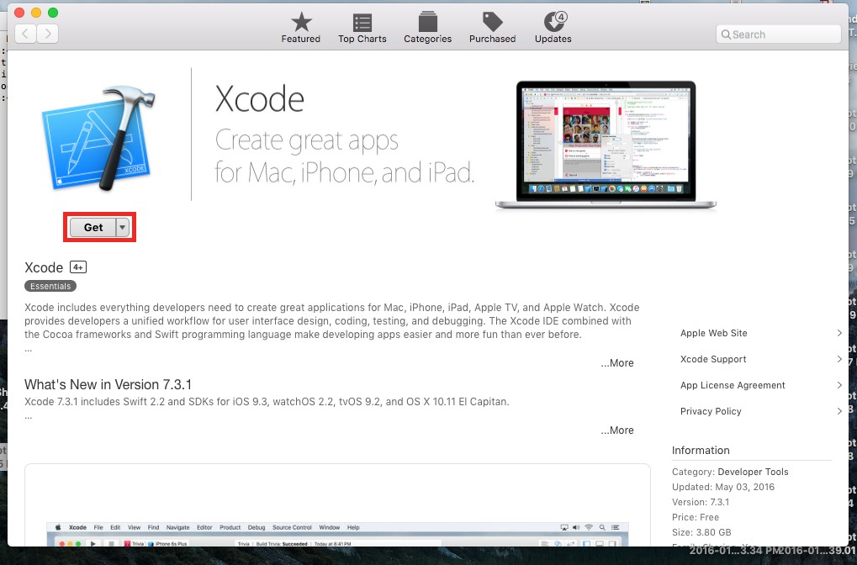

***NOTE:*** the installation may not initiate until you’ve completed particular software updates. To check, click the **Updates** tab and select **Update All**

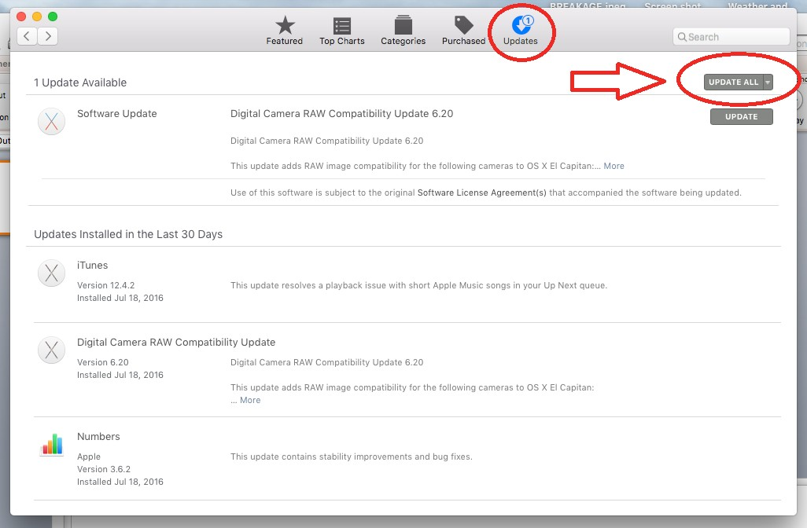

To monitor the installation’s progress, open **Spotlight Search** by pressing **Command + Spacebar** and type in/open up **Launchpad**

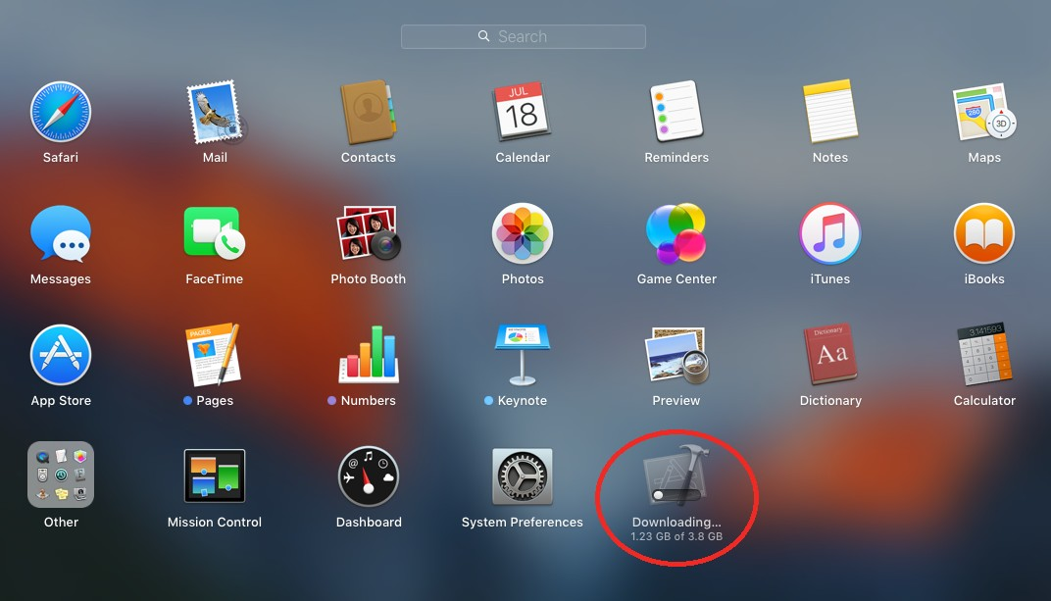

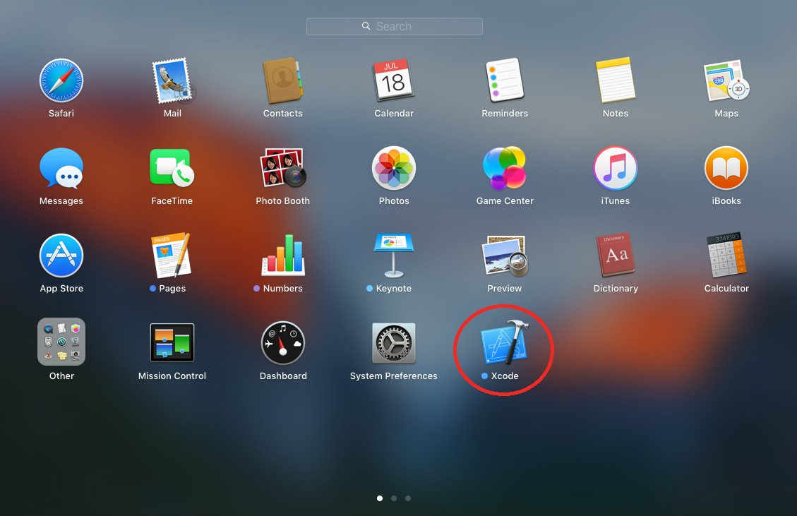

## Creating your first project...

Upon opening Xcode, you’ll see this screen. Click on “**Create a new Xcode Project**”

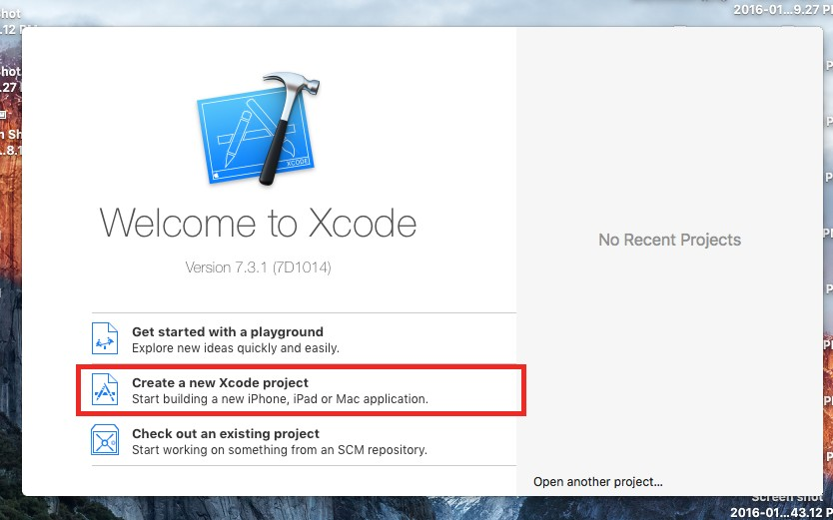

On the right hand side, you’ll notice a selection of different app templates. Select “**Single­View Application**” and click **Next**

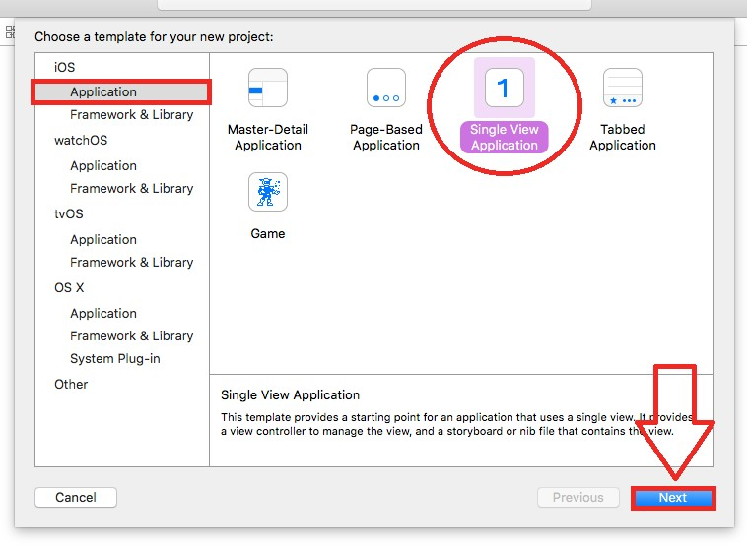

**Product Name**: This is the name that will appear for users in the store and should be similar to the app name you’d later enter into iTunes. Let's name this “**MyFirstProject**.”

**Organization Name**: Affects not only the **Bundle Identifier**, but the Bundle Identifier of every other application. Leave it as it is for now. The top of all your files will likely say your name, but we can edit that out later if need be.

**Organization Identifier**: Set this to “**com.example.[Your Name]**” where ­ like in the picture above ­ [Your Name] represents your Organization Name after being shortened down: the Organization name **David Murphy** is changed to **dmurphy**.

The **Devices** tab lists the different devices that you'd like your app to run off of. For now, leave **Universal** as the selected option and click **Next.** On the next window hit **Create** after choosing your desired location ­ **Desktop** is assigned as default.

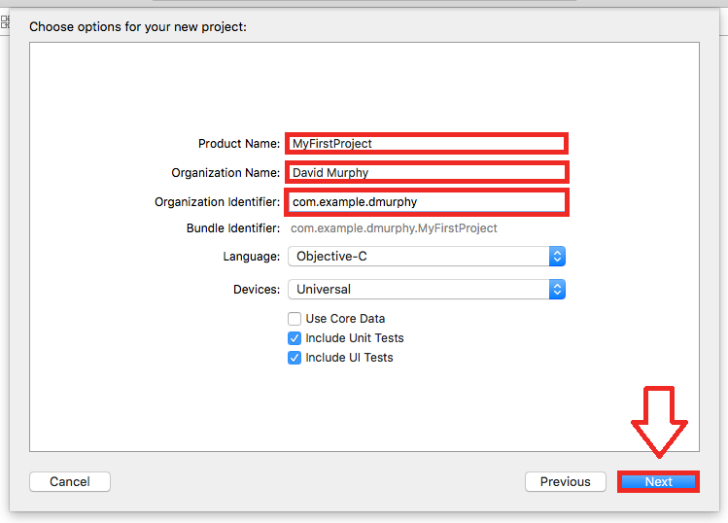

## Congratulations! You’ve created your first Xcode Project!

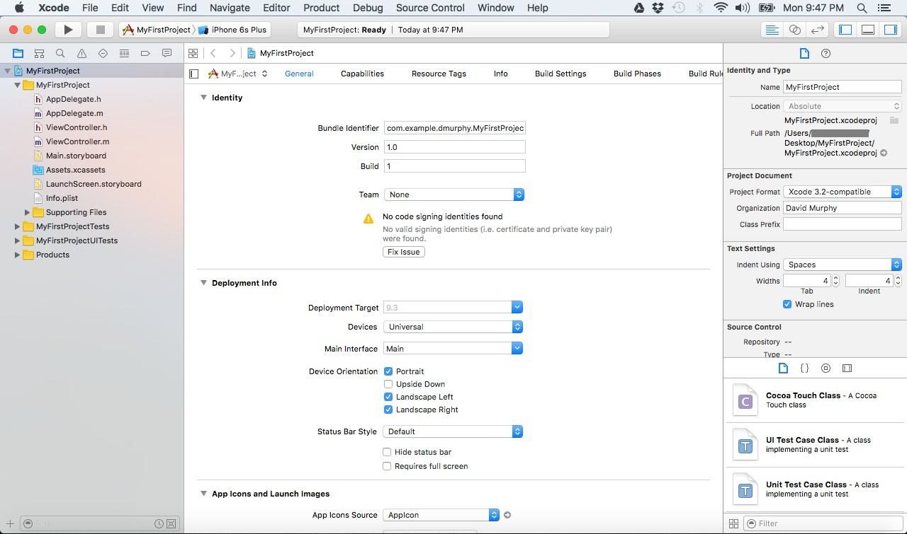



## Installing Xcode Command Line Tools…

Xcode has ***almost*** everything you’ll need to program apps in a tightly packed 3.8 GB download; however, most developers will be coding more than just iOS applications, and most Macs come unequipped with the Unix tools that would otherwise let developers branch off into other territories of programming. The decision to exclude them was made to conserve space and avoid unnecessary storage usage, as Unix Tools were deemed necessary for iOS app developers.

To install Xcode Command Line Tools, navigate to your device's **Terminal** app again through **Spotlight Search**. Then, type “**xcode­select ­­install**” into your terminal and hit **Enter**

Instead of clicking “Get Xcode” like before, find and click **Install** at the bottom­right­hand corner of the new window

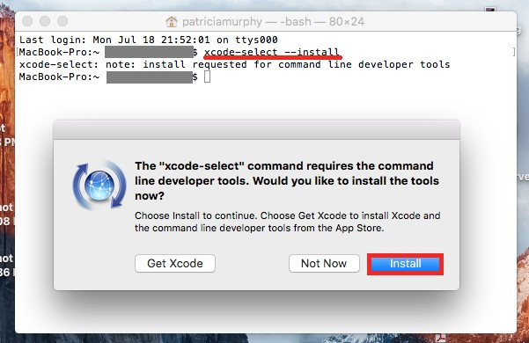

***NOTE*** If Xcode Command Line Tools was previously downloaded onto your device, you’ll likely get an error that resembles the one I received on my screen below:

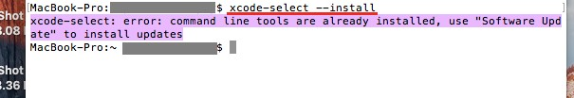

A **Terms and Agreement** screen will: Read it (or don’t); if you accept Apple’s Terms, then hit **Agree** to proceed with the installation

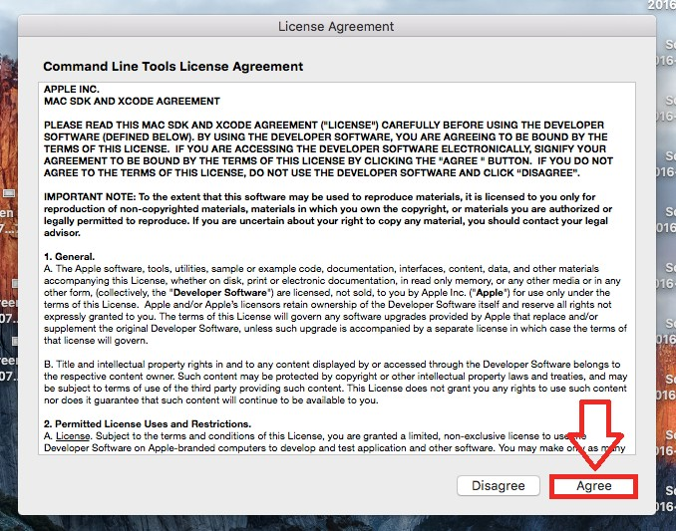

Once the installation is complete, click **Done**

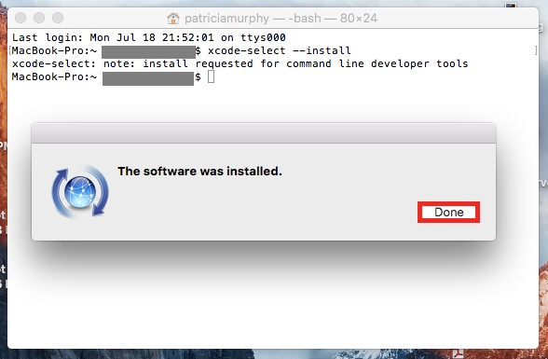

Just to verify that you’ve downloaded the correct version, type “**gcc ­­version**” and the terminal will spit back the version that’s currently installed. Your version should either match or be more updated than the one highlighted below.

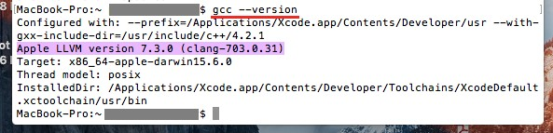

The entire command line toolkit package is located by default at**/Library/Developer/CommandLineTools/**.

## Congratulations! You’ve successfully downloaded Xcode Command Line Tools!

 0

You might also like this articles

Dominick Wojtas



25 July

# [Mobile App Design Guide: Sketch Vs. Photoshop](https://messapps.com/academy/articles/mobile-app-design-guide-sketch-vs-photoshop/)

The debate between Sketch and Photoshop is blazing stronger than ever. Photoshop has been the most commonly used tool when making mockups for mobile and web design for years. However, it seems that the days of Photoshop’s reign in the industry are no more. Sketch has been bubbling quietly for some time now but with the latest release of Sketch 3, I wouldn’t be surprised if Adobe is panicking about losing some of its market share.

0

Dominick Wojtas

31 July

# [What You Need To Do in the Pre-launch Phase of Your App’s Life](https://messapps.com/academy/articles/need-pre-launch-phase-apps-life/)

Once you’ve entered the pre­launch phase in your app’s life, you must turn your attention over to marketing and planning. This part of the process is crucial to the success of your app.

0